IMRI-PL 24 June 2019

SUBJECT: USAG Rock Island Arsenal (RIA) 2019 Integrated Protection Exercise (Tornado Incident) conducted on Wednesday, 19 June 2019 from 0800 to 1700.

BLUF: The training scenario was a Tornado Incident which caused significant damage on the western end of Rock Island Arsenal. The event met exercise goals and objectives. No injuries to personnel or damage to property reported. Personnel from the Quad Cities National Weather Service (NWS), RIA Tenant Commands and Organizations and the Garrison staff particitpated in the training. The purpose of the exercise was test and improve the Installations ability to protect against, mitigate, respond to, and recover from a severe weather natural disaster incident.

DISCUSSION:

There were three separate components of the exercise:

- A Rehearsal of Concept was conducted on 12 Jun 19 to review and discuss RIA procedures for responding to a tornado incident on RIA. The discussion revealed a capability gap in the RIA Army Disaster Personnel Accountability and Assessment System (ADPAAS) Program. The Garrison Commander made a decision to postpone the ADPAAS Drill portion of the exercise until after the program can be fully developed. Exercise severe weather forecast reports were prepared by the NWS and issued to RIA leaders and workforce.

- On 18 June 2019, the RIA Crisis Management Team (CMT), which consist of senior leaders and representatives from the various RIA tenant commands and organization, and members of the Garrison Installation Emergency Operations Center (EOC) were recalled to receive a weather forecast and to develop a mitigation plan for the anticipated severe weather warning / alert.

- The actual exercise started on Wednesday, 19 Jun 19 at 0815 with a mass warning ALERT! Mass Warning and Notificaiton System message to the RIA workforce directing personnel to “Take Shelter” due to an impending Tornado strike on RIA. Exercise observers, sourced from various RIA tenants, were positioned at across RIA to observe the “Take Shelter” portion of the exercise. The EOC was activated. RIA Tenant Commands participated in a personnel accountability drill. The Emergency Family Assistance Center was activated to test notification procedures. ASC conducted a Continuity of Operations (COOP) functional exercise. A battle update brief (BUB) was provided to the Garrison Commander. A table top exercise was conducted in the late afternoon on 19 June 19 to discuss severe weather recovery actions / operations. The Garrison Commander declared the exercise complete at 1630, 19 Jun 19.

INITIAL EXERCISE ASSESSMENTS:
11 of 27 IMCOM Garrison Capabilities Assessed Goals and Objectives
1-Planning | P | Test Mass Warning System (ALERT!) | P
2-Public Information & Warning | P | Activate / Exercise EOC and CMT | T
3-Operational Coordination | P | Activate the EFAC | P
4-Intelligence & Information Sharing | P | Conduct a Personnel Accountability Drill | P
10-Risk Mitigation for Protection Programs | P | Conduct “Take Shelter” Drills | P
12-Risk & Disaster Resilience Assessment | P | Support Tenant COOP Functional Exercise(s) | P
16-Fatalty Criticial Resource Logistics Distribution | P | Conduct a Recovery Table Top Exercise | P
19-Logistics & Supply Chain Management | P | Improve WebEOC usage | P
20-Mass Care | P | Conduct a RIA specific ADPAAS Drill | U
23-Operational Commications | T | Tenants: Review Emergency Action Plans | P
25-Situational Assessment | P | Capture lessons learned / AAR | P
Legend: T = Trained P = Practiced U = Untrained

USAG RIA 2019 Integrated Protection Exercise Training Sessions

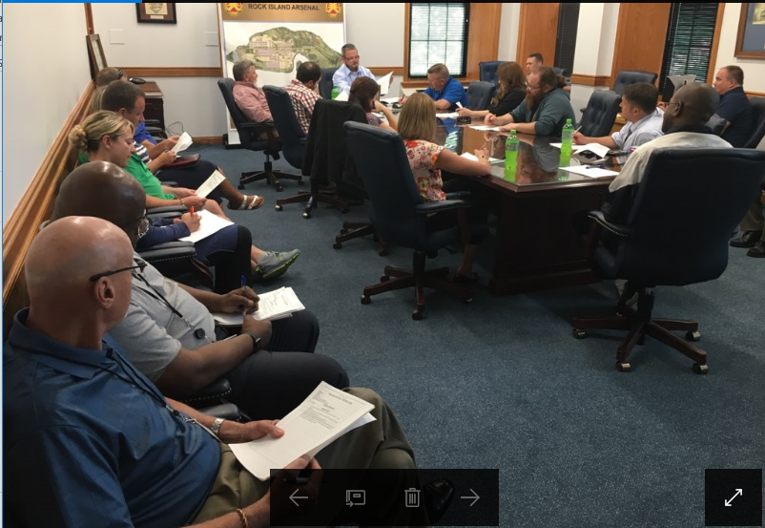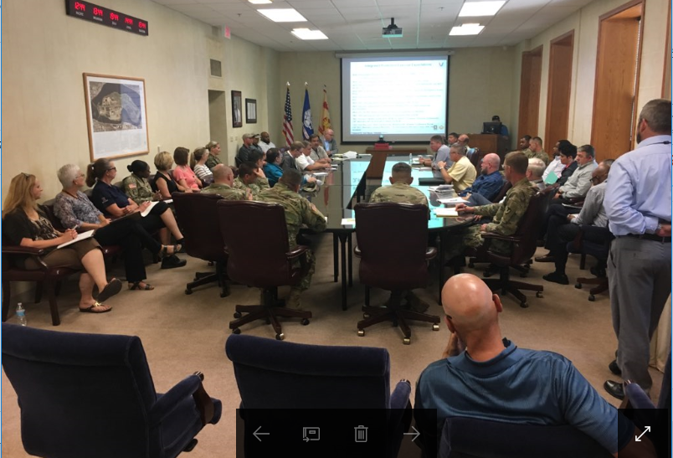

IPE Observer Training Crisis Management Team Recall

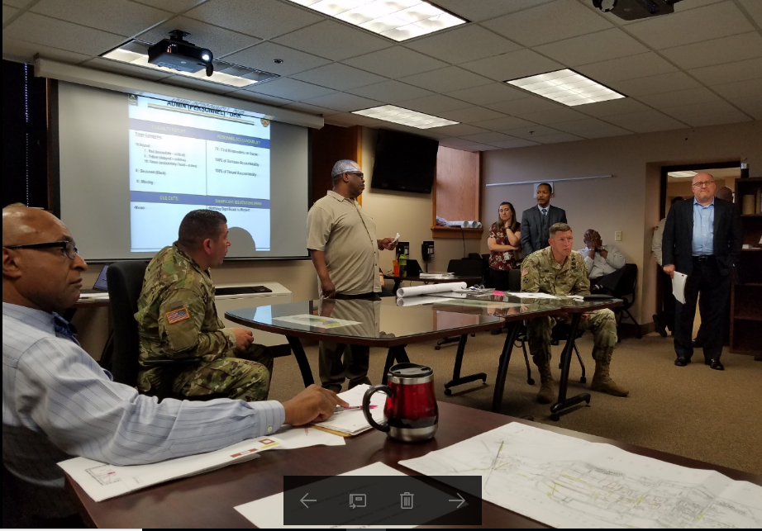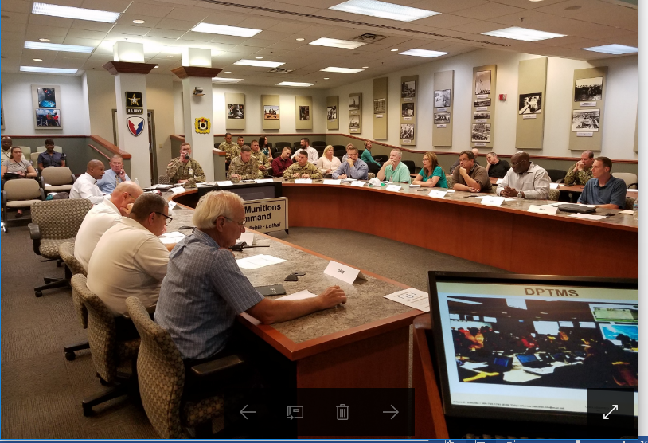

Emergency Operations Center Updates Recovery Table Top Exercise

EXERCISE SUSTAIN:

- Process for recalling the Crisis Management Team and Emergency Operation Center
- Usage of WebEOC to establish a common operation picture (COP)
- Tenant support in providing personnel to serve as Exercise Observers

EXERCISE IMPROVE:

- Refine and exercise the Installation communication plan
- Fully develop logistic capabilities list
- Develop, implement and exercise a specific RIA ADPAAS Program

WAY AHEAD: Publish a Commander’s Action Plan NLT 15 July 2019

PREPARED BY: Mr. Dean Jordan, USAG RIA Director, DPTMS, USAG RIA
dean.jordan.civ@mail.mil or (309) 782-8706

APPROVED BY: COL Steve Marr, Garrison Commander, USAG RIA stephen.c.marr@mail.mil or (309) 782-7772

