

Fort Stewart

Full-Scale Exercise (FSE)

Controller & Evaluator (C/E) Handbook

14 Apr 2021

The Controller/Evaluator (C/E) Handbook describes the roles and responsibilities of exercise controllers and evaluators, and the procedures they should follow. Because the C/E Handbook contains information about the scenario and about exercise administration, it is distributed to only those individuals specifically designated as controllers or evaluators; it should not be provided to exercise players. The C/E Handbook may supplement the Exercise Plan (ExPlan) or be a standalone document.

*NOTE: This C/E Handbook builds upon the base ExPlan, it does not restate core information.*

# Exercise Overview

### Exercise Objectives and Core Capabilities

The following exercise objectives in Table 1 describe the expected outcomes for the exercise. The objectives are linked to core capabilities, which are distinct critical elements necessary to achieve the specific mission area(s). The objectives and aligned core capabilities are guided by elected and appointed officials and selected by the Exercise Planning Team.

| **Exercise Objective** | **Core Capability** |
| --- | --- |
| **Objective 1:** Validate the Fort Stewart Garrison Emergency Management Plan. Establish and maintain a unified and coordinated operational structure and processes that appropriately integrate all critical stakeholders and supports the execution of Core Capabilities. | CC1. Planning  CC3. Operational Coordination  CC4. Intelligence and Information Sharing  CC13. Threat & Hazard Identification  CC15. Env. Response/Health & Safety  CC22. On-Scene Security, Protection & LE  CC23. Operational Communications  CC24. Public Health and Medical Services  CC25. Situational Assessment |
| **Objective 2:** Demonstrate Fort Stewart’s ability to deliver coordinated, prompt, reliable, and actionable information to the whole community through the use of clear, consistent, accessible, other appropriate methods to effectively relay information regarding any threat or hazard and, as appropriate, the actions being taken and the assistance being made available. | CC2. Public Information & Warning  CC3. Operational Coordination  CC4. Intelligence and Information Sharing  CC11. Community Resilience  CC23. Operational Communications  CC25. Situational Assessment  CC26. Health & Social Services |
| **Objective 3:** Validate the EFAC plan by providing life-sustaining and human services to the affected population, to include hydration, feeding, sheltering, temporary housing, evacuee support, reunification, and distribution of emergency supplies. | CC2. Public Information & Warning  CC3. Operational Coordination  CC4. Intelligence and Information Sharing  CC11. Community Resilience  CC20. Mass Care Services  CC22. On-Scene Security, Protection & LE  CC23. Operational Communications  CC24. Public Health and Medical Services  CC25. Situational Assessment  CC26. Health & Social Services |
| **Objective 4:** Conduct appropriate measures to ensure the protection of the health and safety of the public and workers, as well as the environment, from all hazards in support of responder operations and the affected communities. Detect, assess, stabilize, and clean up releases of hazardous materials into the environment, including buildings/structures, and properly manage waste. | CC2. Public Information & Warning  CC3. Operational Coordination  CC4. Intelligence and Information Sharing  CC13. Threat & Hazard Identification  CC15. Env. Response/Health & Safety  CC20. Mass Care Services  CC22. On-Scene Security, Protection & LE  CC23. Operational Communications  CC24. Public Health and Medical Services  CC25. Situational Assessment  CC26. Health & Social Services |

# Exercise Control Information and Guidance

### Controller Package

The controller package consists of this C/E Handbook, activity logs, badges, and other exercise tools (e.g., MSEL) as necessary. Controllers must bring their packages and any additional professional materials specific to their assigned exercise activities.

### Scenario Tools

The MSEL outlines benchmarks and injects that drive exercise play. It also details realistic input to exercise players, as well as information expected to emanate from simulated organizations (i.e., nonparticipating organizations or individuals who usually would respond to the situation). The MSEL consists of the following two parts:

* **Timeline.** This is a list of key exercise events, including scheduled injects and expected player actions. The timeline is used to track exercise events relative to desired response activities.
* **Injects.**  An individual event inject is a detailed description of each exercise event. The inject includes the following pieces of information: scenario time, intended recipient, responsible controller, inject type, a short description of the event, and the expected player action.

## Exercise Control

### Exercise Control Responsibilities

The following table details exercise control responsibilities.

| EXCON Responsibilities |
| --- |
| **Exercise Director** |
| * Oversees all exercise functions * Oversees and remains in contact with controllers and evaluators * Oversees setup and cleanup of exercise, and positioning of controllers and evaluators |
| **Senior Controller** |
| * Monitors exercise progress * Coordinates decisions regarding deviations or significant changes to the scenario * Monitors controller actions and ensures implementation of designed or modified actions at the appropriate time * Debriefs controllers and evaluators after the exercise * Oversees setup and takedown of the exercise |
| **Safety Controller** |
| * Monitors exercise safety during exercise setup, conduct, and cleanup * Receives any reports of safety concerns from other controllers or participants |
| **Public Information Officer (PIO)** |
| * Provides escort for observers * Provides narration and explanation during exercise events, as needed * Performs pre-exercise and post-exercise public affairs duties * May act as media briefer and escort at exercise site * Serves as safety officer for his or her site |
| **Venue Controller** |
| * Issues exercise materials to players * Monitors exercise timeline * Provides input to players (i.e., injects) as described in MSEL * Serves as safety officer for his or her site |
| **White Cell / Simulator** |
| * Role-plays as non-participating organizations or individuals * Monitors exercise timeline * Provides input to players (i.e., injects) as described in MSEL |

Table 3. Controller Responsibilities

## Exercise Control Instructions

### Before the Exercise

* Review appropriate emergency plans, procedures, and protocols.
* Review appropriate exercise package materials, including the objectives, scenario, injects, safety and security plans, and controller instructions.
* Attend required briefings.
* Report to the exercise check-in location at the time designated in the exercise schedule, meet with the exercise staff, and present the Player Briefing.
* Be at the appropriate location at least 15 minutes before the exercise starts.
* Obtain, locate and test necessary communications equipment.

### During the Exercise

* Wear controller identification items (e.g., badge).
* Avoid personal conversations with exercise players.
* If you have been given injects, deliver them to appropriate players at the time indicated in the MSEL (or as directed by the Exercise Director). **Note:** If the information depends on some action to be taken by the player, do not deliver the inject until the player has earned the information by successfully accomplishing the required action.
* When you deliver an inject, notify the White Cell and note the time that you delivered the inject and player actions.
* Receive and record exercise information from players that would be directed to nonparticipating organizations.
* Observe and record exercise artificialities that interfere with exercise realism. If exercise artificialities interfere with exercise play, report it to the Exercise Director.
* Begin and end all exercise communications with the statement, **“Exercise, Exercise, Exercise.”**
* Do not prompt players regarding what a specific response should be, unless an inject directs you to do so. Clarify information but do not provide coaching.
* Ensure that all observers and media personnel stay out of the exercise activity area. If you need assistance, notify the Exercise Director.
* Do not give information to players about scenario event progress or other participants’ methods of problem resolution. Players are expected to obtain information through their own resources.

### After the Exercise

* At the conclusion of exercise play, the garrison controllers facilitate a Hot Wash to allow players to discuss strengths and areas for improvement and allow evaluators to seek clarification regarding player actions and decision-making processes. All participants may attend; however, evaluators/observers do not lead nor engage in the Hot Wash. The Hot Wash should not exceed 30 minutes.
* At exercise termination, summarize your notes from the exercise and Hot Wash, and prepare for the Controller and Evaluator Debriefing. Have your summary ready for the Exercise Director.

# Evaluator Information and Guidance

## Exercise Evaluation Overview

Exercise evaluation assesses an organization’s capabilities to accomplish a mission, function, or objective. Evaluation provides an opportunity to assess performance of critical tasks to capability target levels. Evaluation is accomplished by the following means:

* Observing the event and collecting supporting data;
* Analyzing collected data to identify strengths and areas for improvement; and
* Reporting exercise outcomes in the AAR.

## Evaluation Documentation

### Evaluator Package

The evaluator package contains this C/E Handbook, EEGs, and other items as necessary. Evaluators should bring the package to the exercise. They may reorganize the material so information that is critical to their specific assignment is readily accessible. Evaluators may bring additional professional materials specific to their assigned activities.

### Exercise Evaluation Guides

EEGs provide a consistent tool to guide exercise observation and data collection. EEGs are aligned to exercise objectives and core capabilities and list the relevant capability targets and critical tasks. Data collected in EEGs by each evaluator will be used to develop the analysis of capabilities in the AAR.

Each evaluator is provided with an EEG for each capability that he/she is assigned to evaluate. Evaluators should complete all assigned EEGs and submit to the Lead Evaluator at the conclusion of the exercise. The Lead Evaluator and Senior Controller compile all evaluator submissions into the first working draft of the AAR.

### After Action Report

The AAR summarizes key information related to evaluation. The main focus of the AAR is the analysis of core capabilities. The AAR is not a critique; does not evaluate success or failure but identifies any capability gaps; command staff will determine overall TPU for installation.

AARs also include basic exercise information, including the exercise name, type of exercise, dates, location, participating organizations, mission area(s), specific threat or hazard, a brief scenario description, and the name of the exercise sponsor and POC. The written formal AAR will be provided within 60 days of the final out brief by IMCOM HQ.

## Evaluator Instructions

### General

* Avoid personal conversations with players.
* Do not give information to players about event progress or other participants’ methods of problem resolution. Players are expected to obtain information through their own resources.

### Before the Exercise

* Review appropriate plans, procedures, and protocols.
* Attend required evaluator training and other briefings.
* Review appropriate exercise materials, including the exercise schedule and evaluator instructions.
* Review the EEGs and other supporting materials for your area of responsibility to ensure that you have a thorough understanding of the core capabilities, capability targets, and critical tasks you are assigned to evaluate.
* Report to the exercise check-in location at the time designated in the exercise schedule and meet with the exercise staff.
* Obtain or locate necessary communications equipment and test it to ensure that you can communicate with other evaluators and the Exercise Director.

### During the Exercise

* Wear evaluator identification items (e.g., vest or badge).
* Stay in proximity to player decision-makers.
* Use EEGs to document performance relative to exercise objectives, core capabilities, capability targets, and critical tasks.
* Focus on critical tasks, as specified in the EEGs.
* Your primary duty is to document performance of core capabilities. After the exercise, that information will be used to determine whether the exercise capability targets were effectively met and to identify strengths and areas for improvement.

### After the Exercise

* Participate in the Hot Wash and take notes on findings identified by players. Before the Hot Wash, do not discuss specific issues or problems with participants. After the Hot Wash, summarize your notes and prepare for the Evaluator Debriefing. Have your summary ready for the Lead Evaluator.
* Complete and submit all EEGs and other documentation to the Lead Evaluator at the end of the exercise.

### Using Exercise Evaluation Guides

#### Terminology

The EEGs are structured to capture information specifically related to the evaluation requirements developed by the Exercise Planning Team. The following evaluation requirements are documented in each EEG:

* **Core capabilities:** The distinct critical elements necessary to achieve a specific mission area (e.g., prevention). To assess both capacity and gaps, each core capability includes capability targets.
* **Capability target(s):** The performance thresholds for each core capability; they state the exact *amount* of capability that players aim to achieve. Capability targets are typically written as quantitative or qualitative statements.
* **Critical tasks:** The distinct elements required to perform a core capability; they describe *how* the capability target will be met. Critical tasks generally include the activities, resources, and responsibilities required to fulfill capability targets. Capability targets and critical tasks are based on operational plans, policies, and procedures to be exercised and tested during the exercise.
* **Performance ratings:**
* Improve: **Major*:** Impacts mission assurance at a critical point; needs addressed ASAP
* Improve: **Significant:** Needs improvement plan in a timely manner with possible mitigation efforts in place
* Improve: **Minor:** Tasks are being met; however, room for improvement exist
* **Sustain**

#### Documenting Observations

For each EEG, evaluators provide a target rating, observation notes and an explanation of the target rating, and a final core capability rating. In order to efficiently complete these sections of the EEG, evaluators should focus their observations on the capability targets and critical tasks listed in the EEG.

Observation notes should include *if* and *how* quantitative or qualitative targets were met. For example, a capability target might state, “*Within 4 hours of the incident….”* Notes on that target should include the actual time required for exercise players to complete the critical tasks. Additionally, observations should include:

* How the target was or was not met;
* Pertinent decisions made and information gathered to make decisions;
* Requests made and how requests were handled;
* Resources utilized;
* Plans, policies, procedures, or legislative authorities used or implemented; and
* Any other factors contributed to the results.

Evaluators should also note if an obvious cause or underlying reason resulted in players not meeting a capability target or critical task. However, the evaluators should not include recommendations in the EEGs.

*Note:* Observation notes for discussion-based exercises will focus on *discussion* of the how critical tasks would be completed, rather than actual actions taken.

#### Assigning Ratings

Based on their observations, evaluators will stratify their observations per guidance given by the lead evaluator.

### Placement and Monitoring

Evaluators should be located so they can observe player actions and hear conversations without interfering with those activities. In certain conditions, more than one evaluator may be needed in a particular setting or area. For exercise site maps highlighting key locations, see Appendix D.

#### Observer Locations **(EXAMPLE Below to overwrite)**

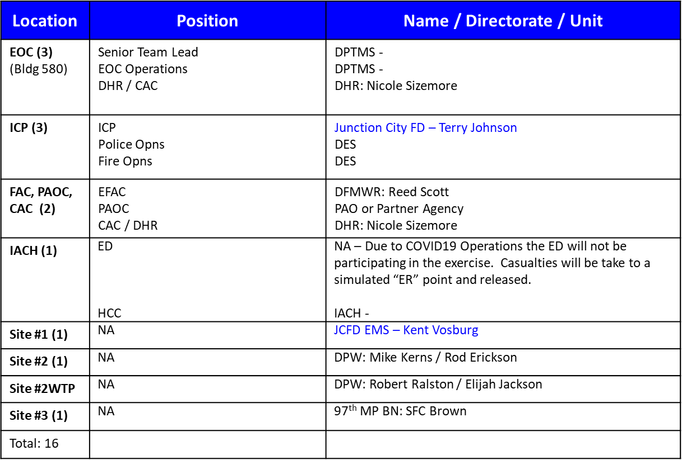

#### Role Players**(EXAMPLE Below to overwrite)**



# Appendix A: Exercise Schedule

[**Note:** Because this information is updated throughout the exercise planning process, appendices may be developed as stand-alone documents rather than part of the C&E.]

| Time | Personnel | Activity | Location | |
| --- | --- | --- | --- | --- |
| 12 Apr (Mon) | | | | |
| 0800-0900 | Design Team and Eval Team | Work areas setup | White Cell & Evaluation Team rooms | |
| 0900-0950 | Design Team and Eval Team | Meet with exercise lead planner to conduct final on-ground coordination. | Lead Planner’s work area | |
| 1000-1100 | Eval Team & Lead Planner | FSE scenario brief to Eval Team by Lead Planner | Eval team work area | |
| 1100-1130 | Eval Team & Lead Planner | Eval Team windshield tour | FSE key locations on installation | |
| 1300-1400 | Design Team & Lead Planner | FSE MSEL finalization | White Cell | |
| 12 Apr (Tue) | | | | |
| 0800-0830 | Design Team, Eval Team & Controllers | FSE MSEL review | Eval Team work area | |
| 0830-0900 | Design Team Lead, Eval Team Chief & IMCOM Rep | GC Pre-brief | Garrison HQ | |
| 0900-1000 | Eval Team, Design Team, Controllers & Garrison Staff | Garrison In-brief/FSE overview | EOC | |
| Design Team overview |
| 1000-1300 | Evaluation Team & Garrison Staff Leads | Counterpart link-up | EOC | |
| 1300-UTC | Eval Team Leads, Design Lead, Lead Planner | FSE Controller finalization | EOC | |
| 14 Apr (Wed) | | | | |
| 0800-UTC | Exercise Participants, Design Team &Eval Team | FSE execution (continued/**tentative**) | | Installation-wide |
| 15 Mar (Thurs) | | | | |
| 0800-UTC | IMCOM Design Team &Eval Team | Develop FSE Outbrief products | | N/A |
| 16 Mar (Fri) | | | | |
| 0830-0900 | Design Team Lead, Eval Team Chief & IMCOM Rep | GC Deskside | | Garrison HQ |
| 0900-1000 | Eval Team Chief, Design Team Lead, Garrison Staff | Garrison/Senior Commander & Staff Outbrief | | EOC |
| 1100-UTC | Design Team, Eval Team | Depart Ft. Stewart and return to home station | |  |

# Appendix B: Exercise Site Maps

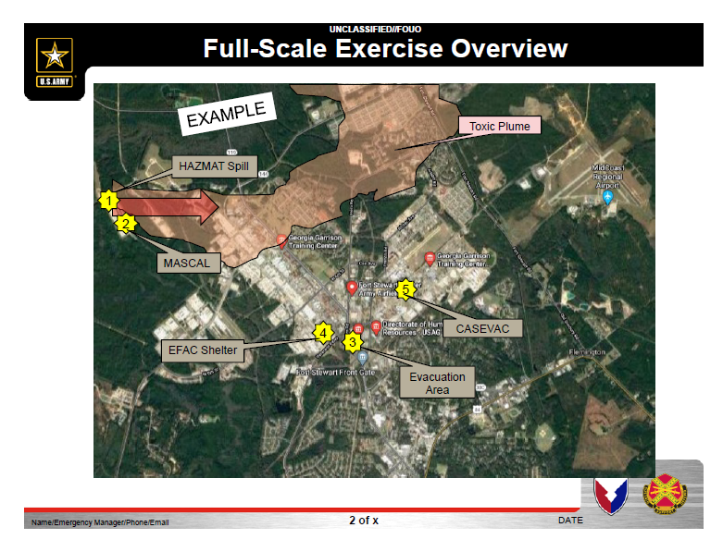

# Vignette #1

# Slide 3.PNG

# Vignette #2

# Slide 4.PNG

# Vignette #3

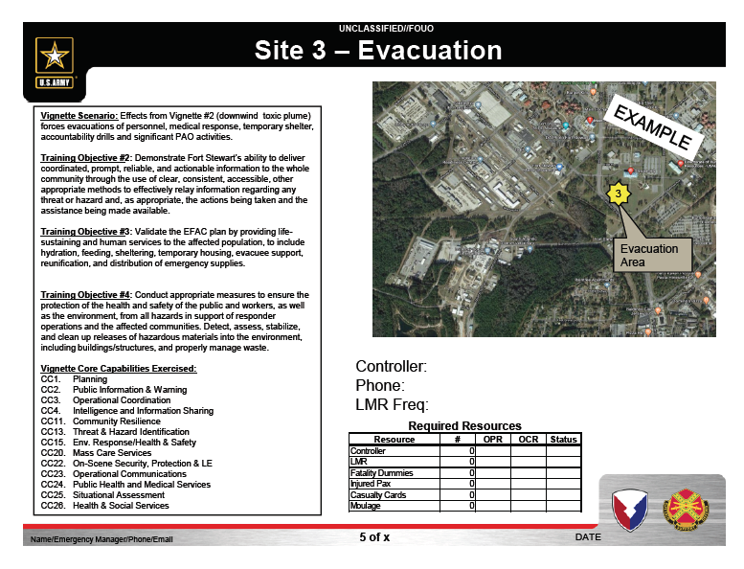

# Vignette #4

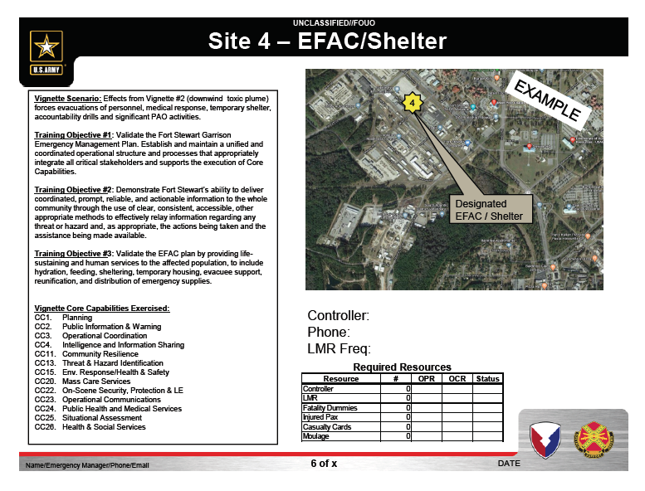

# Vignette #5

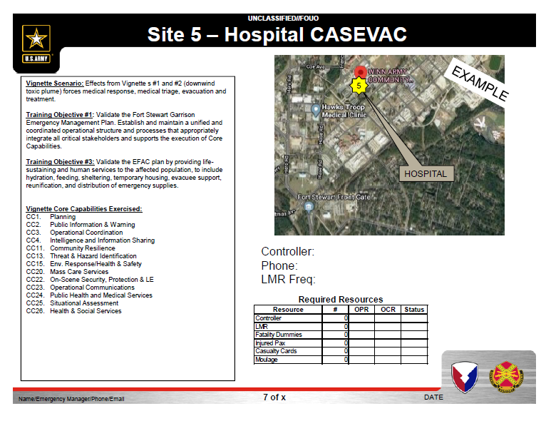

# Appendix C: Communications Plan

The below communications plan is used by controllers/evaluators during the Full Scale Exercise.

***All communications (including written, radio, telephone, and e-mail) during the exercise will begin and end with the statement “Exercise, Exercise, Exercise.”***

### Fort Stewart’s primary EOC exercise landline numbers are:

### a. BC1 XXX-XXXX

### b. BC2 XXX-XXXX

### Fort Stewart’s primary Dispatch exercise landlinenumber is: XXX-XXXX

### Tactical communication is Land Mobile Radio to Fort Stewart IOC channel (IOC HQ).

|  |  |  |  |
| --- | --- | --- | --- |
| **FORT STEWART EMERGENCY CORE AND SECONDARY** | | | |
| **Unit / Organization** | **EOC Phone #** | **Unit / Organization** | **EOC Phone #** |
| **Primary CAT Members** |  | **Extended Members** |  |
| EOC Chief |  | CID |  |
| Battle Captain (1) |  | DECA |  |
| Battle Captain (2) |  | CSLA |  |
| DPW |  | DFAS |  |
| LRC |  | DOC |  |
| RMO |  | JITC |  |
| DHR |  | EPG |  |
| MEDDAC |  | EXCHANGE |  |
| RSO |  | USAISEC |  |
| ESB |  | ISEC |  |
| DES |  | NETCOM |  |
| PAO |  |  |  |
| DFMWR |  |  |  |

# Appendix D: Acronyms

| **Acronym** | **Term** |
| --- | --- |
| AAR | After Action Report |
| C/E | Controllers / Evaluators |
| CONOPS | Concept of Operations |
| DES | Directorate of Emergency Services |
| DFMWR | Directorate of Family Morale Welfare and Recreation |
| DHR | Directorate of Human Resources |
| DHS | Department of Homeland Security |
| DPTMS | Directorate of Plans, Training, Mobilization and Security |
| DPW | Directorate of Public Works |
| DRM | Directorate of Resource Management |
| EEG | Exercise Evaluation Guide |
| EOC | Emergency Operations Center |
| ExPlan | Exercise Plan |
| FSE | Full-Scale Exercise |
| HSEEP | Homeland Security Exercise and Evaluation Program |
| IP | Improvement Plan |
| MSEL | Master Scenario Events List |
| OBJ | Objectives |
| O/C | Observers / Controllers |
| PAO | Public Affairs Office |
| POC | Point of Contact |
| SME | Subject Matter Expert |
| USAG | United States Army Garrison |